Test Report:Login module

1. Module Name:

Login Module

1. Objective:

To verify and validate the functionality, error handling, input validation, and user authentication of the login module in a web-based application.

1. Environment Details :

Parameter Value

Application URL https://accounts.spotify.com/login

OS Windows 10

Browser Google Chrome

1. Test scenarios covered:

* Valid login with correct credentials
* Invalid login with wrong password
* Login attempt with blank fields
* Login with unregistered user
* Redirect after login
* Session management after login/logout

1. Test cases:
2. **Open login page of spotify.**

* URL of spotify is (https://accounts.spotify.com/login).

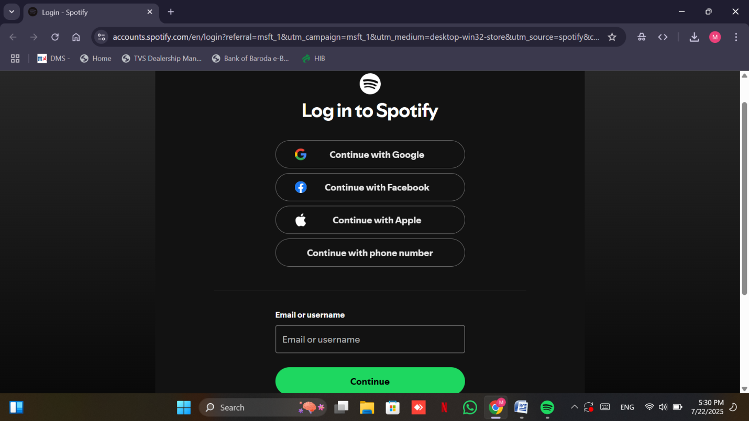

1. **Valid login with correct credentials**

* Enter username or email id.

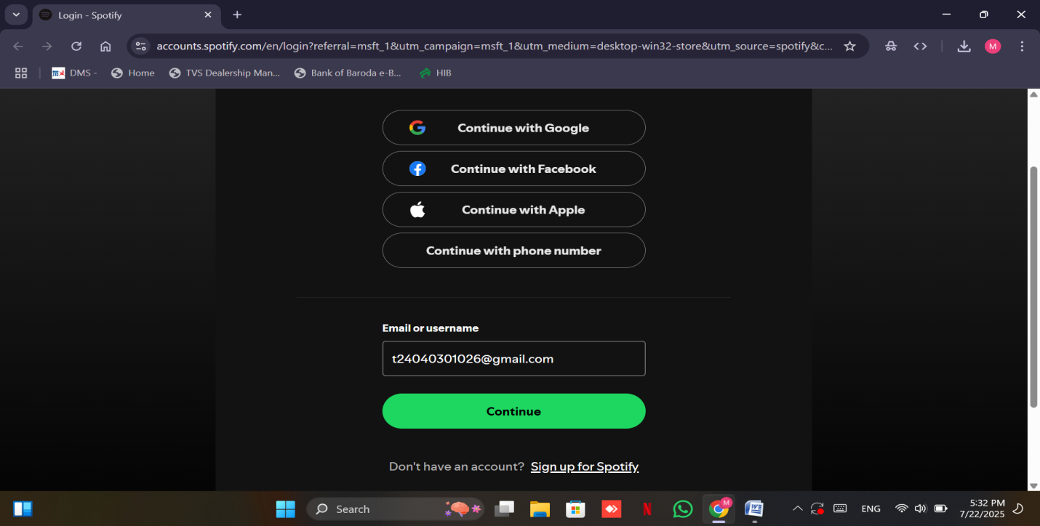

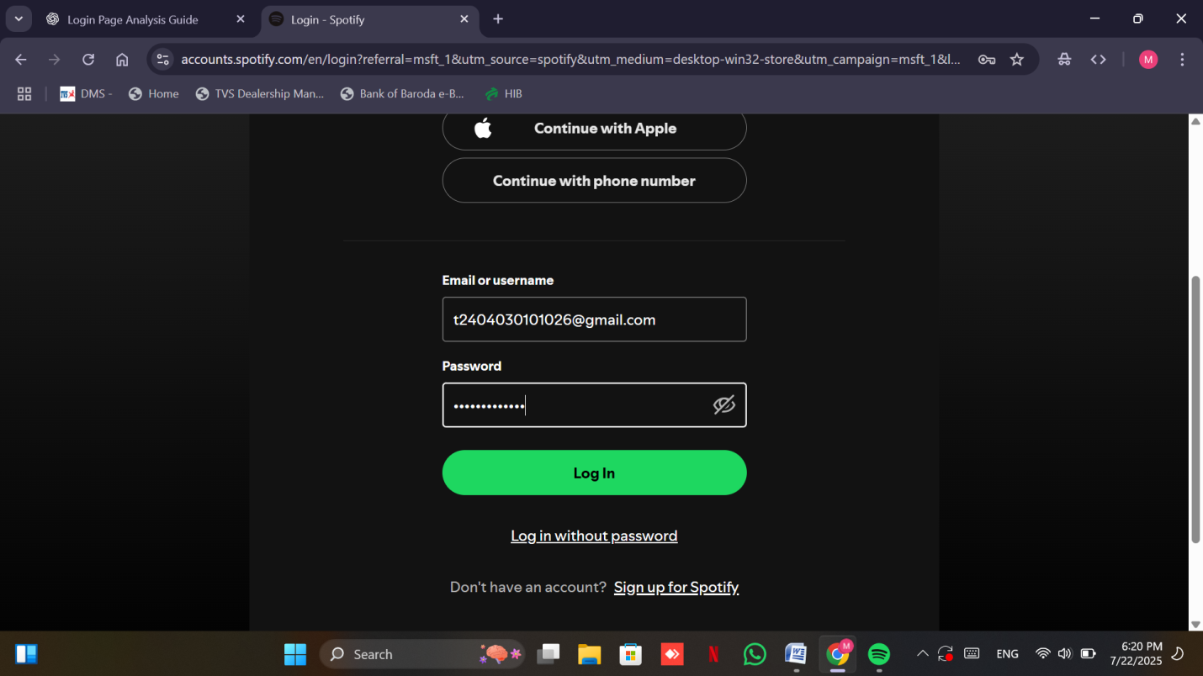

* Enter the password.
* Then click the login button to proceed.
* In the end spotify home page will be opened.

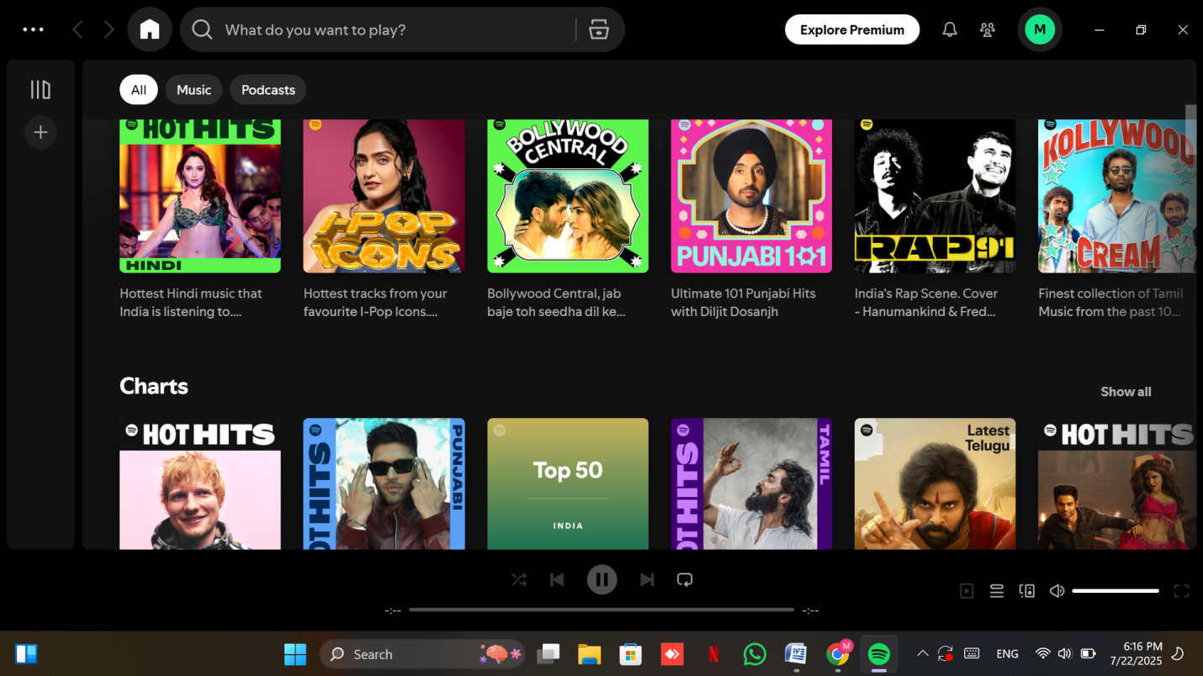

**Spotify uses two main login-related buttons**:

* Login page access button.
* Submit/login button.

Both buttons are responsive and function on the first click.

1. **Invalid login with wrong email and password**

* For email/username validation form does not accept invalid or incomplete id.

For example entering incorrect format of email like picture given below.

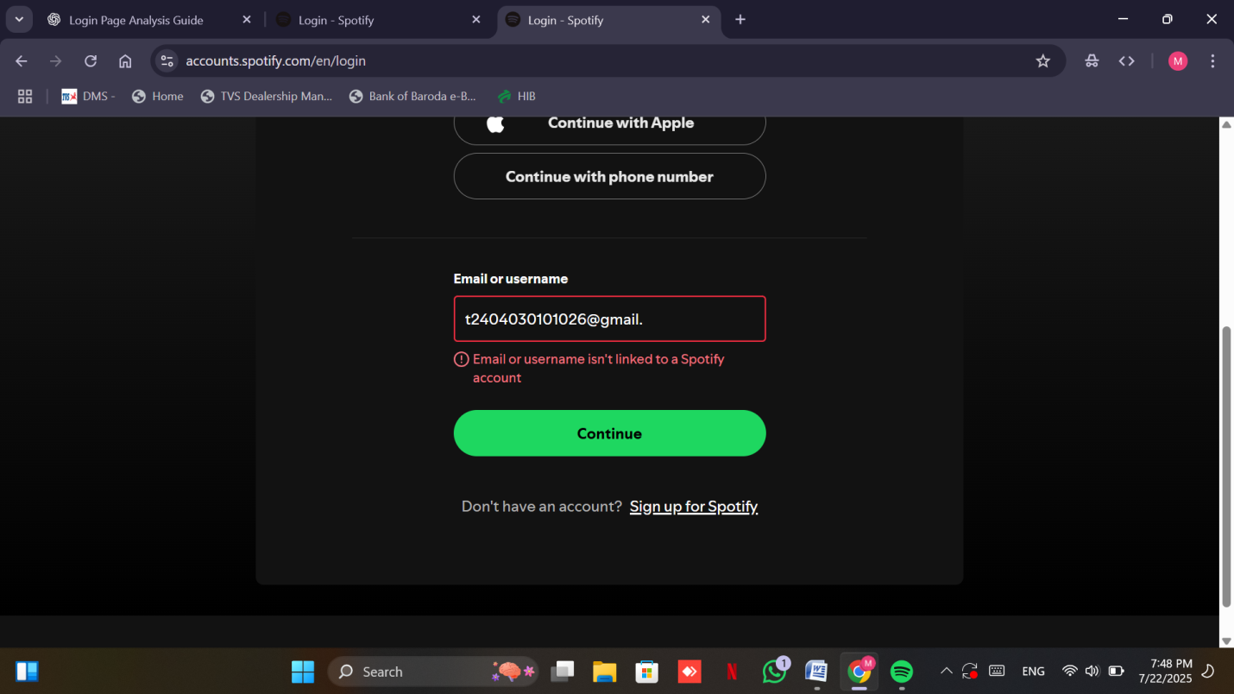

* **Password Validation**

Entering an incorrect password triggers a visible **error message**.

The system does not allow login with wrong credentials.

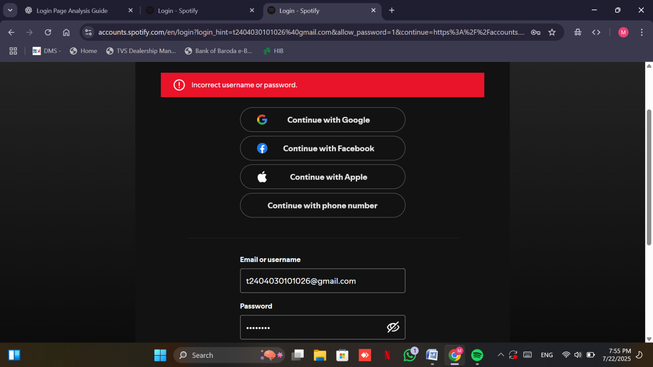

#### **Additional Security Option**

#### If users forget their password, Spotify offers a **verification code** system.

* + A code is sent to the registered email ID to complete the login process
  + This adds a layer of security and user-friendliness. 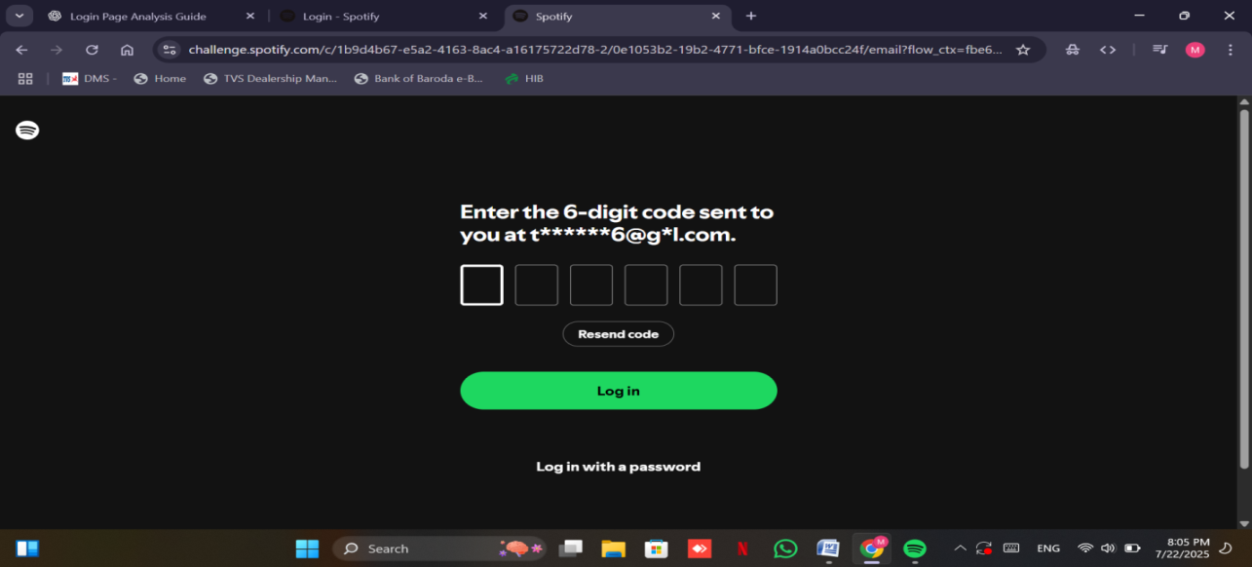

1. **Login attempt with blank fields**

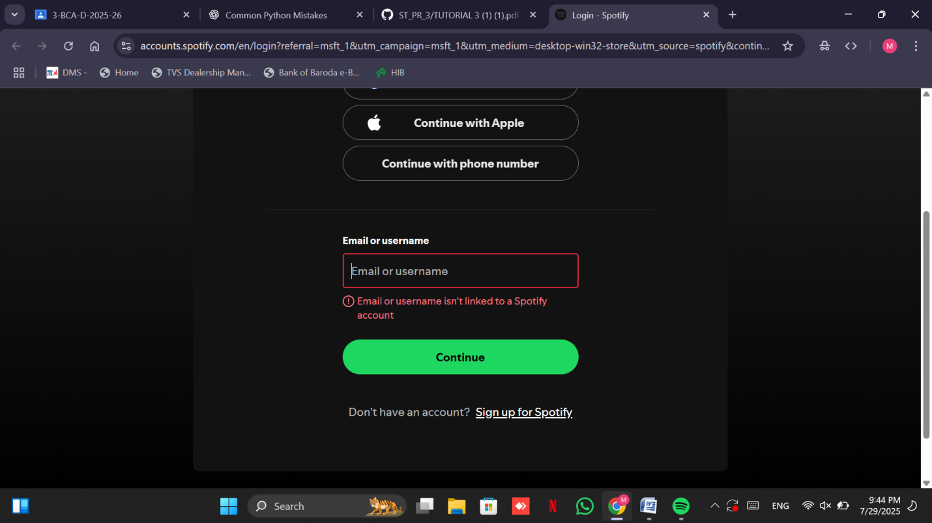

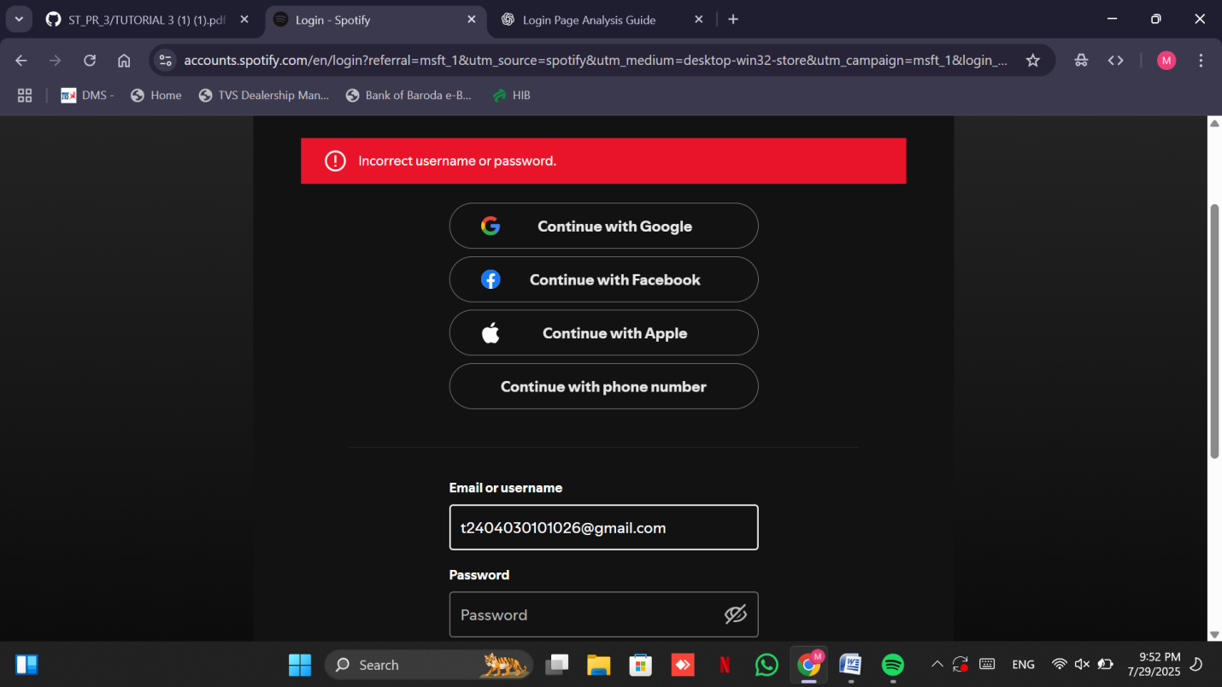

Attempting to log in without filling in the required fields triggers Spotify’s built-in input validation:

• If the **email/username field is left blank**, an error message appears prompting the user to enter valid credentials.

• If the **password field is also left blank**, the system does not allow submission.

1. **Login with unregistered use**

This test simulates an attempt to log in using an email ID or username that **does not exist in Spotify’s database**.

* When an **unregistered username or email** is entered .
* The login attempt is **rejected immediately** after clicking the login button.

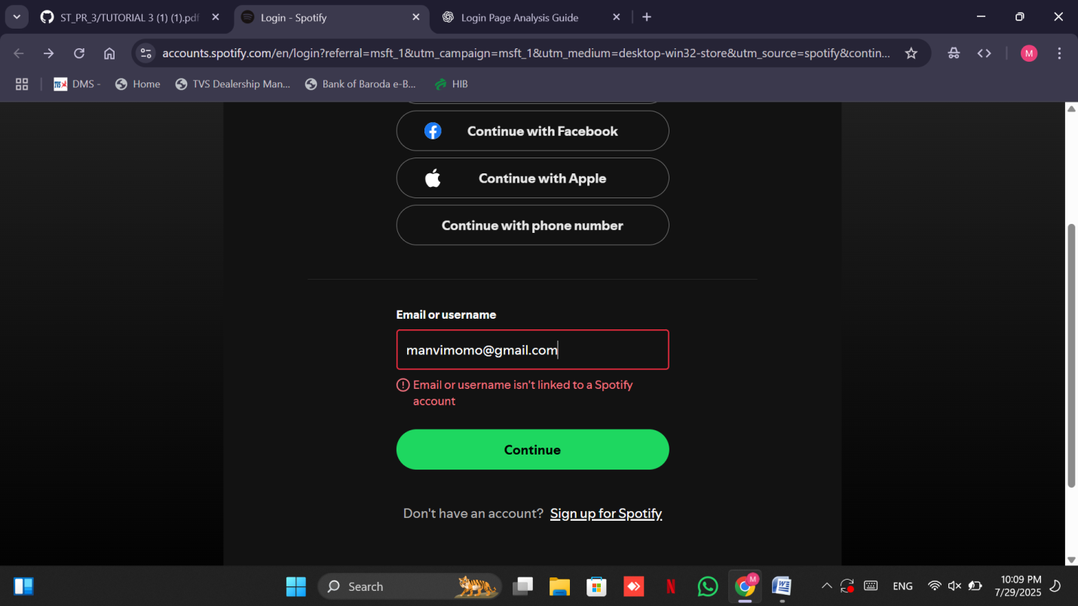

### ****Redirect After Successful Login****

### This step evaluates what happens **immediately after a user logs in successfully**.

* After entering **valid credentials**, the user is instantly redirected to:  
   Spotify’s Web Player homepage.



### 7. ****Session Management After Login/Logout****

This section examines how Spotify handles user sessions after logging in and logging out — a key factor in **security**, **usability**, and **browser behavior**.

#### ****After Login:****

* Once logged in, the session is **automatically maintained**, even if the user:
  + Refreshes the page
  + Closes and reopens the tab
  + Navigates around different sections of the site

This shows that Spotify uses **persistent session cookies** (often lasting days or even weeks) to keep users logged in for convenience.

**After Logout:**

* When the user **logs out manually**, the session is terminated and:
  + The user is redirected to the **login page**
  + All session cookies are invalidated (user can’t just hit back and re-enter)
  + Trying to access any **logged-in only pages** after logout will bounce the user **back to the login screen**

This means Spotify is **properly destroying session data** on logout, preventing unauthorized re-entry.

**8. Bug Reports**

Bug Report 1

Field Description

Bud ID BUG001

Title Wrong error message shown when login fields are

Blank

Module login

Severity Medium

Steps to 1. Go to login page

Reproduce 2. Leave Email and Password empty

3. Click Login

Expected Result Sow error:”Fields cannot be empty”

Actual Result Show error:”incorrect email and password”

Status Not open

9.  **Conclusion and Recommendations**

* Pass Rate:85%, Needs Improvement
* Input validations protection must be implemented properly.
* UI/UX should include client-side and server-side validations.
* High-priority bugs must be fixed before moving to production.